# Technical Design Document: Programming Exercise 2

# Name: Lucas Korzeniewski
# Date: June 14, 2026
# Program Description: The program scans a message that the user inputs and compares it to a list of common phrases used in spam emails. It then creates a score based on how many of these phrases are detected and shows how likely the message is to be a scam based on that score.

## Function: CalculateSpamScore()
This function scans the email message for spam words and phrases. It
counts how many times each keyword appears, calculates the spam score,
and stores the keywords that were found.

Parameters:
EmailMessage (string): The email message entered by the user.

Variables:
SpamScore (integer): Stores the total score
FoundWords (list of strings): stores the spam keywords detected
Keyword (string): used to access each spam keyword in the list
Occurences (integer): stores the amount of times a keyword is detected

Logic:
- Convert the email message to lowercase.
- Set the spam score to zero.
- Create an empty list to store detected spam words.
- Loop through each keyword in the spam keyword list.
- Count how many times the keyword appears in the email.
- If the keyword appears one or more times: Add the number of occurrences to the spam score. Add the keyword and occurrence count to the list of found words.
- Return the spam score and the list of found words.
Return:
SpamScore (integer)
FoundWords (list of strings)

## Function: DetermineSpamLikelihood()
This function determines the likelihood that an email is spam based on
the calculated spam score.

Parameters:
SpamScore (integer): Stores the total score

Variables:
No additional variables used.

Logic:
- Check the value of the spam score
- Compare the score to predefined ranges
- Assign the spam likelihood rating.
- Return the rating

Return:
Likelihood (string)

#Link to your repository: https://github.com/lucask333?tab=repositories
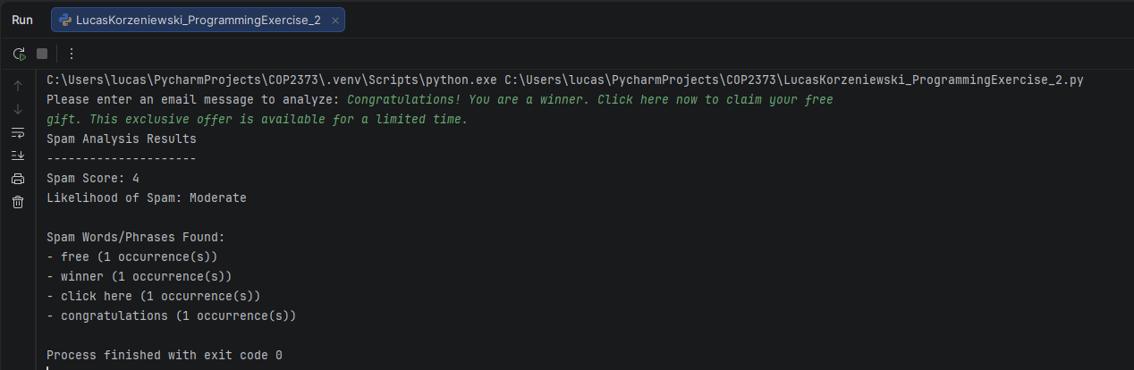
Output Screenshot: (make sure big enough so I can see)

